A simple todo app built with Django

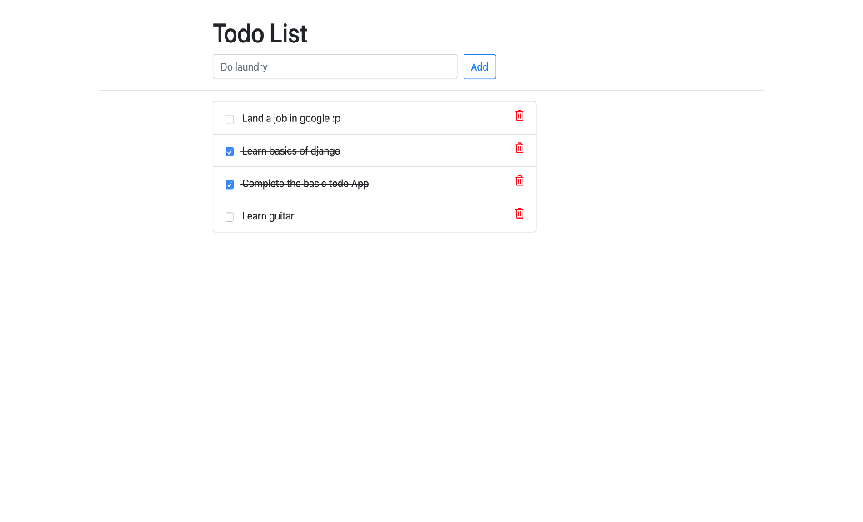

1. sudo apt-get update
2. git clone <https://github.com/yeshwanthlm/django-on-ec2.git>
3. sudo apt install python3-pip -y
4. pip install Django
5. ls
6. cd Django_on_ec2
7. ls -lrt
8. python3 manage.py makemigrations
9. python3 manage.py migrate
10. python3 manage.py createsuperuser

username

email

pasowrd

re_pasowrd

1. python3 manage.py runserver
2. python3 manage.py runserver 0.0.0.0:8000
3. copy <public_ip:8000> of server and paste in browser to see TODO_LIST